Lab 6:

Task 1 Screen shots:

Host U can communicate with VPN Server:

VPN Server can communicate with Host V:

Host U should not be able to communicate with Host V:

Run tcpdump on the router, and sniff the traffic on each of the network. Show that you can capture

Packets:

I have transmitted two packets from client-server container and captured them successfully:

I have transmitted packets from host container and captured them successfully:

Task 2.a: Name of the Interface:

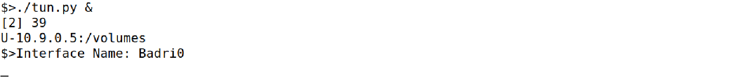

Task 2.b: Set up the TUN Interface

Task 2.c: Read from the TUN Interface

n Host U, ping a host in the 192.168.53.0/24 network:

On Host U, ping a host in the internal network 192.168.60.0/24

Task 2.d: Write to the TUN Interface:

After getting a packet from the TUN interface, if this packet is an ICMP echo request packet, construct a corresponding echo reply packet and write it to the TUN interface. Please provide evidence to show that the code works as expected.

Instead of writing an IP packet to the interface, write some arbitrary data to the interface, and report your observation:

Code screenshot:

Output screenshot:

Run the tun server.py program on VPN Server, and then run tun client.py on Host U. To test whether the tunnel works or not, ping any IP address belonging to the 192.168.53.0/24 network:

Running tun_client program on host u screenshot:

Vpn server screenshot:

Adding ip route:

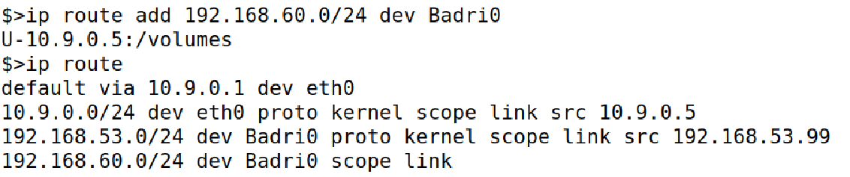

ping an IP address in the 192.168.60.0/24 network, the ICMP packets are received by tun server.py through the tunnel:

pining ip address:



Tun_server.py screenshots:

*last two entries are proof that tun_server received packets when we ping 192.168.60.5

Task 3: Send the IP Packet to VPN Server Through a Tunnel:

Running tun_server:



Pining 192.168.60.5:

it is sufficient to show (using Wireshark or tcpdump) that the ICMP packets have arrived at Host V:

Task 5: Handling Traffic in Both Directions:

Code screenshot:

Client.py:

Server.py:

Once this is done, we should be able to communicate with Machine V from Machine U, and the VPN tunnel (un-encrypted) is now complete. Please show your wireshark proof using about ping and telnet commands.

Trying telent connection if everything is set properly telnet connection should be successful, please look into below screenshot for proof:

Screenshot 1:

Screenshot 2:

In your proof, you need to point out how your packets flow:

Task 6: Tunnel-Breaking Experiment:

Running telnet command:

Stopping server program:

Checking weather I can type on telnet interface, I’m not to type:



Task 7: Routing Experiment on Host V:

